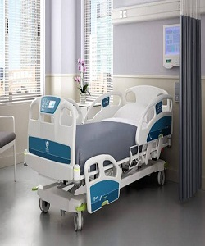

Edra Hospital bed

$152.95

Availability: In stock

**Description:**

Modern loft-style light steel Hospital bed .White Leather Queen Size Bed - Steal-A-Sofa Furniture Outlet Los Angeles CA Add this white leatherette upholstered bed to any room in your Hospital for a sleek and comfort to your patient. Perfect for a Hospital that’s classic and functional, this is the ideal starter piece for your patients. Hospital Collection that will look stunning in your newly built or renovated. Modern white flat bed with electrical wheels to ensure stability and support.